# WORKSHEET 1.1 – Answer Sheet

# Object-Oriented Programming

1. The bottom of the figure is at the point (0,0).

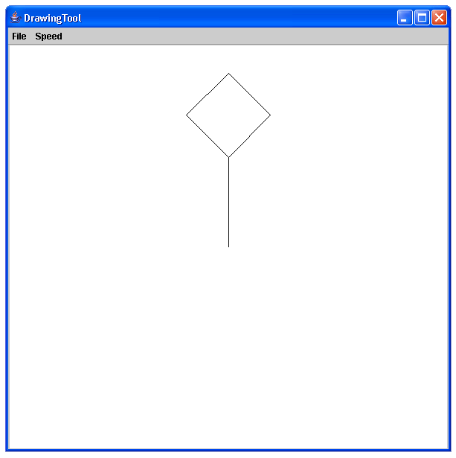

2. Two parallel lines A and B. Line A is 200 units long with its midpoint at the point (0,0). Line B is 350 units long with its midpoint at (0,100).

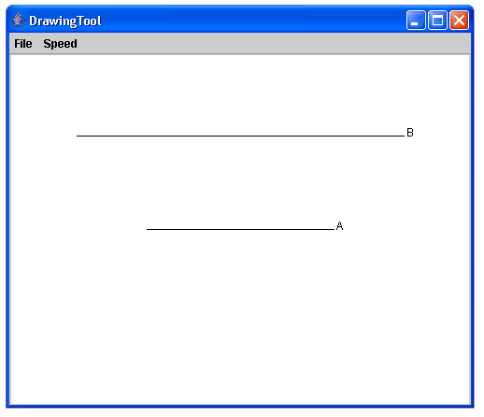

3. // square

marker.move(200,0);

marker.move(200,200);

marker.move(0,200);

marker.move(0,0);

marker.up();

// mouth

marker.move(40,60);

marker.down();

marker.move(40,40);

marker.move(160,40);  
marker.move(160,60);

marker.up();

// nose

marker.move(100,100);

marker.down();

marker.move(85,85);

marker.move(100,85);

marker.up();

// eyes

marker.move(60,150);

marker.down();

marker.drawCircle(10);

marker.up();

marker.move(140,150);

marker.down();

marker.drawCircle(10);

4. marker.up();

marker.move(-100,0);

marker.down();

marker.move(175,100);

marker.up();

marker.move(100,0);

marker.down();

marker.move(-175,100);

The above code, when added to # 2, will create the following figure:

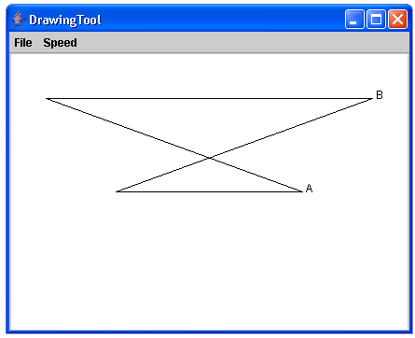

5. marker.up();

marker.move(0,125);

marker.down();

marker.move(0,-25);

The above code, when added to # 2, will create the following figure:

